Name: Harsh Ratna

PRN: 21070126032

Div: AIML(A2)

JAVA Assignment-10

CODE:-

**ThreadDemo.java**

package threading;  
class Printer extends Thread{  
 String message;  
 public void setMessage(String message)  
 {  
 this.message = message;  
 }  
 @Override  
 public void run()  
 {  
 for(char ch:message.toCharArray())  
 {  
 try {  
 Thread.*sleep*(500);  
  
 } catch (InterruptedException e) {  
 e.getStackTrace();  
 }  
 System.*out*.print(ch);  
  
 }  
 }  
}  
public class ThreadDemo {  
 public static void main(String[] args) {  
 // Creating instance of Printer class.--------------------------------->  
 Printer printer = new Printer();  
 printer.setName("Thread1");   
 printer.setMessage("Hello, how are you ?"); // Calling the setMessage function of the Printer class.  
 System.*out*.println(printer.getName());  
 printer.start(); // Thread will start  
  
  
 // Creating another instance of the Printer class.---------------------------->  
 Printer anotherPrinter = new Printer();  
 anotherPrinter.setName("Thread2");  
 anotherPrinter.setMessage("I am fine");  
 anotherPrinter.start();  
 System.*out*.println("End of Main"); // This is printed first because after this main method dies and non demon thread continuous to work even after the main method dies.  
  
 }  
}

OUTPUT:-

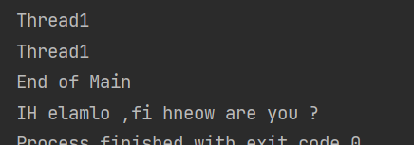

**Github:**

**https:** [Java-Programs/assignment-10 at main · Harsh5425/Java-Programs (github.com)](https://github.com/Harsh5425/Java-Programs/tree/main/assignment-10)